**ONLINE MUSIC STORE**

Description:

The online music store website is developed sell copyright music albums and songs to users. Users can search for songs or albums and buy the songs through the website. The website has an admin login functionality where only the administrator can edit or delete songs. The songs deleted are soft delete i.e. the deleted songs won’t be deleted from the database but, they will not be displayed on the website.

Database Design:

# Create tables

# Music tables: album, track, mood, genre

“create table album (album_id char(32), album_name char(50), artist char(30), year int, album_art char(80), artist_art char(80), primary key (album_id));"

“create table track (track_id char(32), album_id char(32),track_name char(20), track_no int(3), length char(5), price char(5), deleted bit DEFAULT 0, primary key (track_id), foreign key (album_id) references album(album_id));”

“create table mood (track_id char(32), mood char(50), foreign key (track_id) references track(track_id));"

"create table genre (track_id char(32), genre char(50), foreign key (track_id) references track(track_id));”

# User tables: user, purchase, cart

“create table user (uname char(10), pwd char(128), admin bit, email char(32), address varchar(100), primary key (uname));”

"create table purchase (purchase_id char(32),uname char(10), date datetime, track_id char(32), foreign key (uname) references user(uname));"

"create table cart (uname char(10), track_id char(32), primary key(uname, track_id), foreign key (uname) references user(uname));”

Languages/framworks:

Database: MySQL

Front End: HTML, CSS, JADE (Pug)

Back End: Node JS, REST API

Screenshots:

Home Page (User):

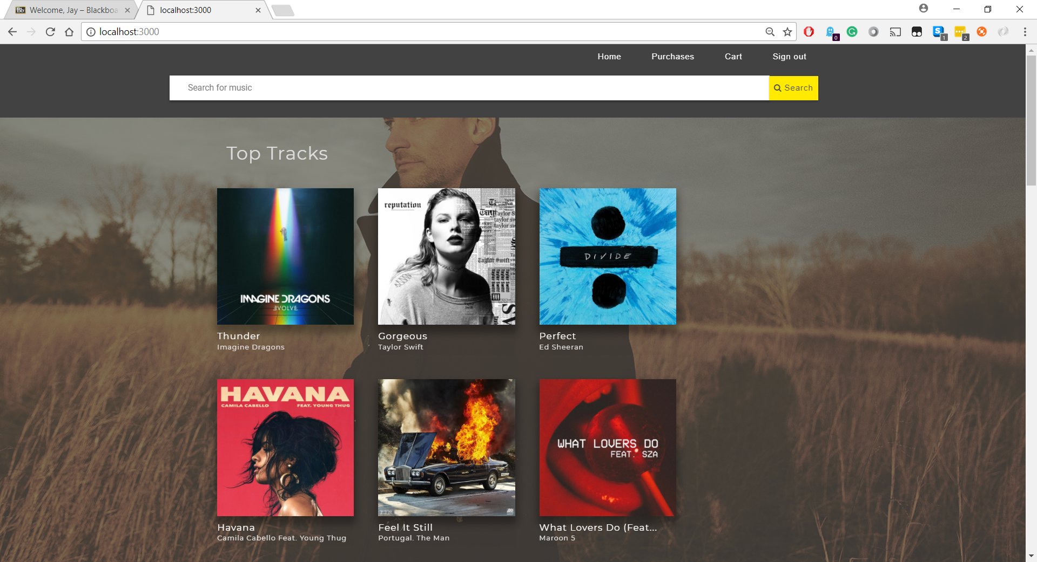

Home Page (Admin):

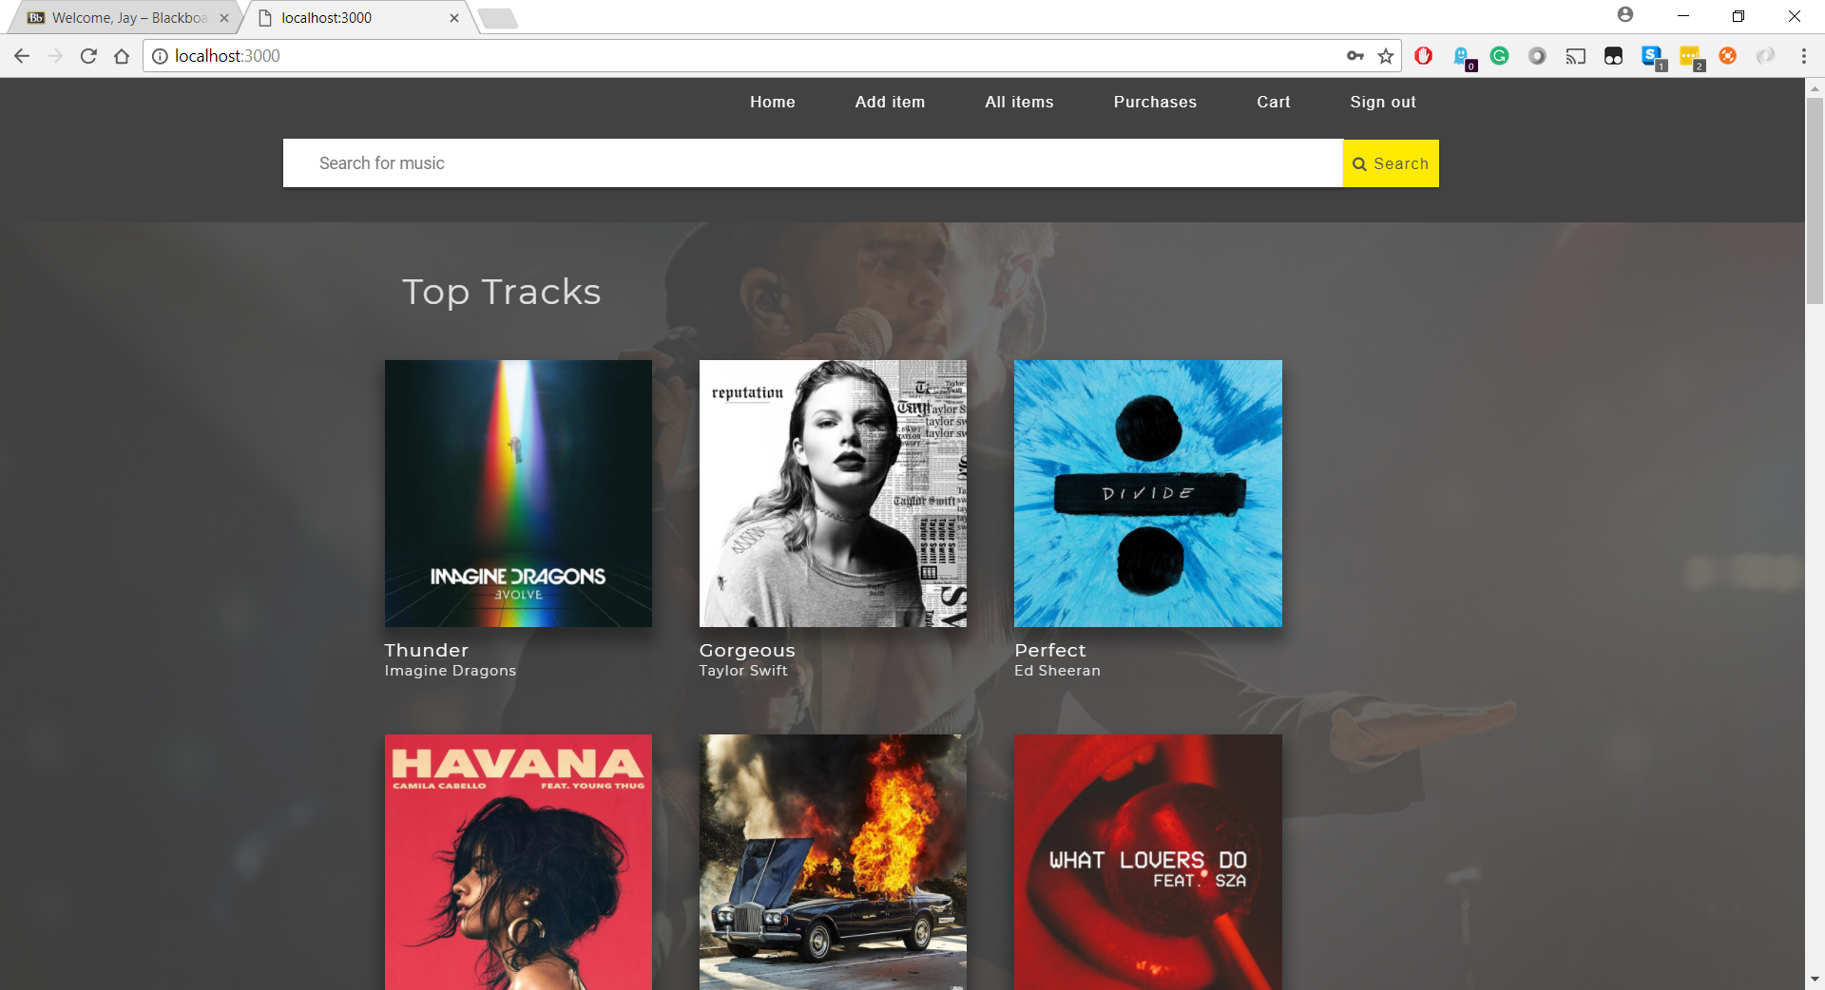

Add_Item/Edit_Item (Admin):

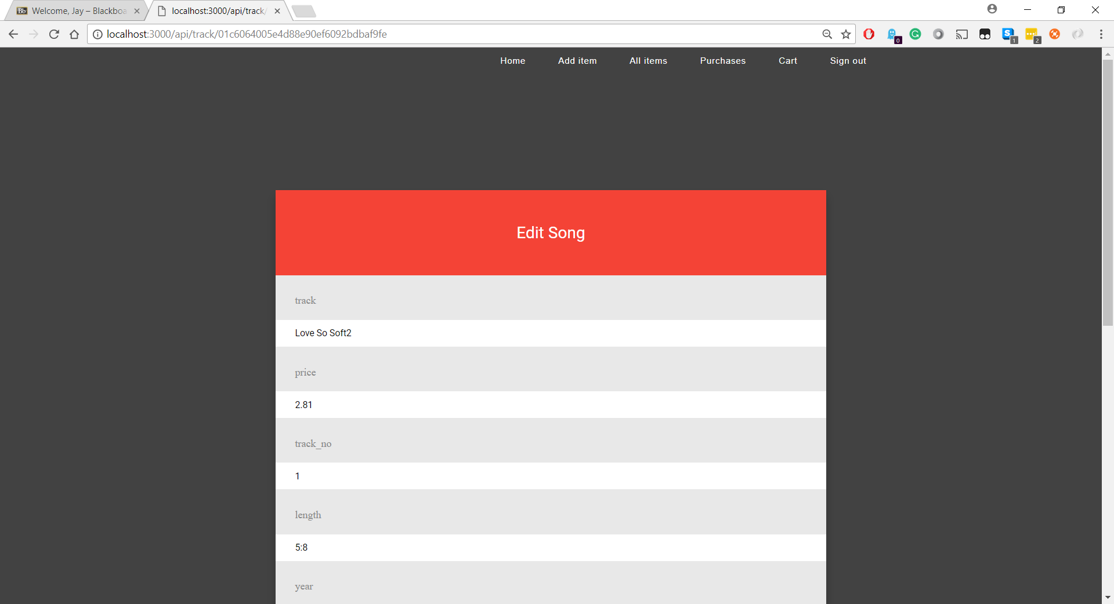

Log In (Admin, User):

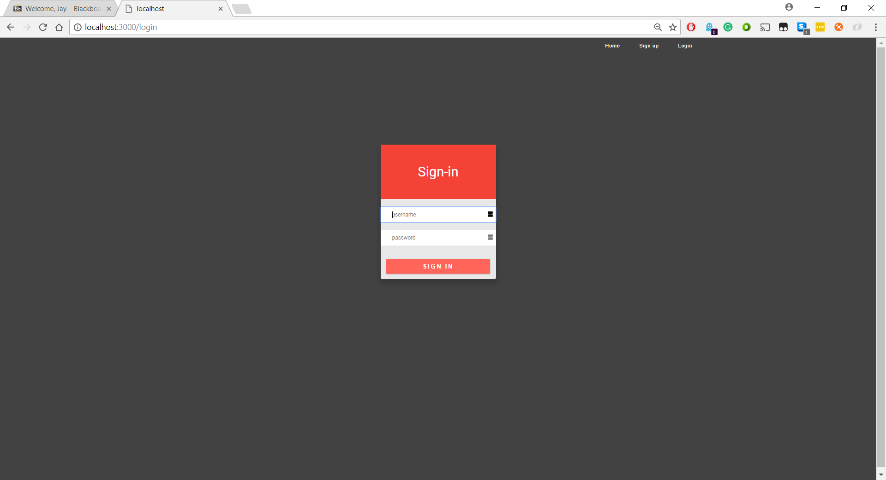

Search (User):

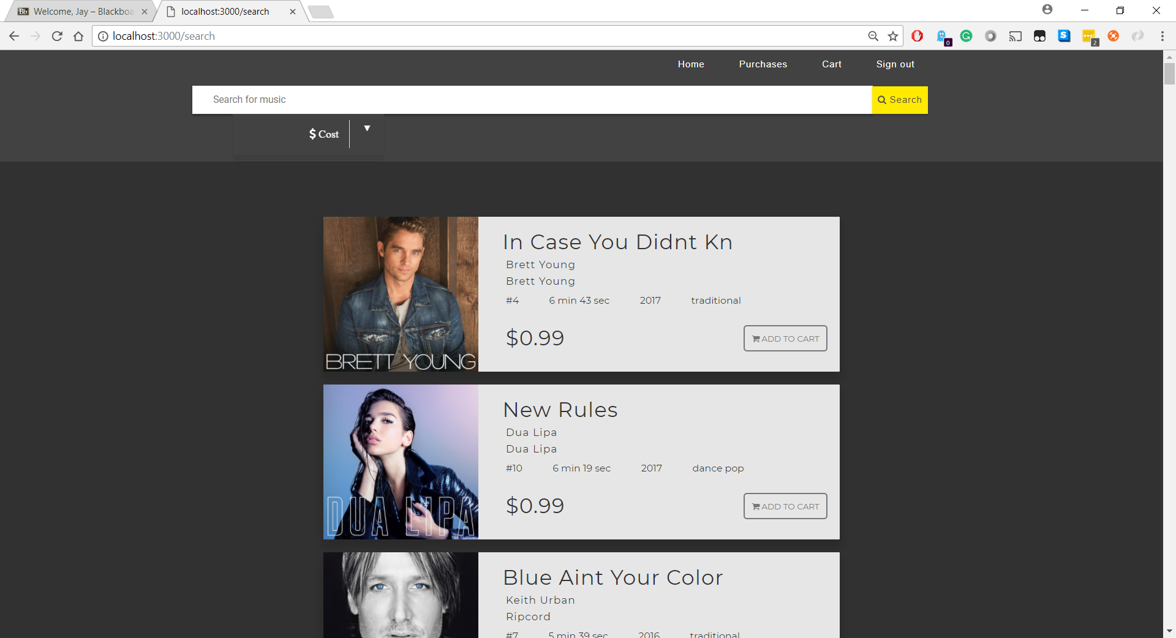

Search (Admin):

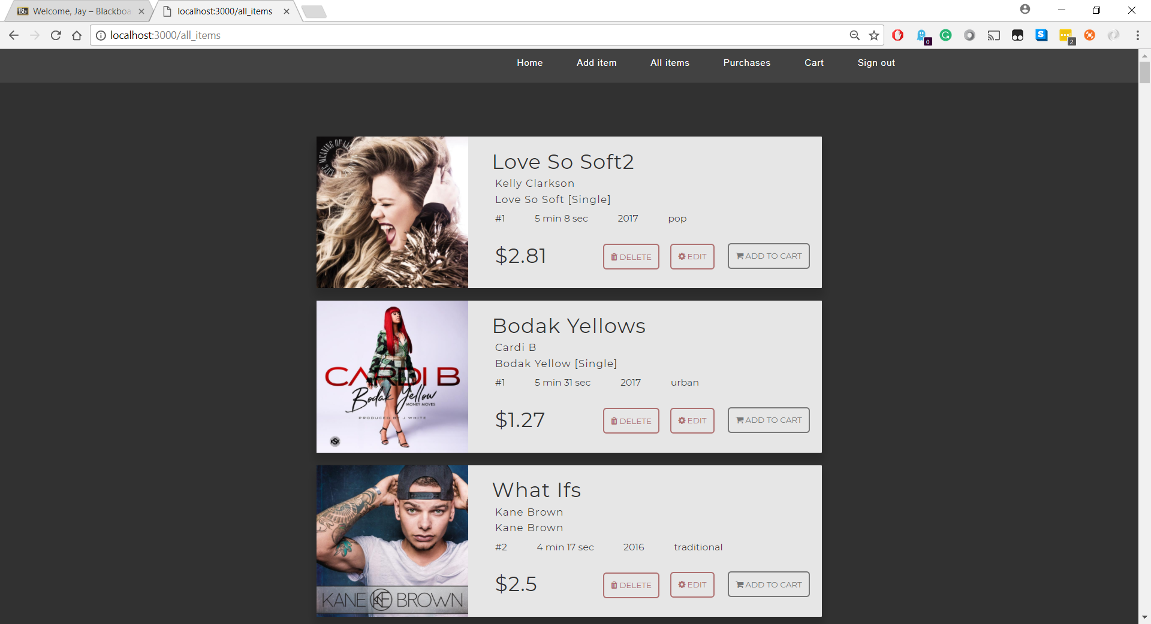

Team Members:

Arijeet Roy: axr165030

Ashoka Leela:

Jay Shah: jas160630

Work Division:

All the team members worked on developing the Database and coming up with a Third Normal from compliant schema. Ashoka worked on developing the front end of the website working on Home_Page, Log-in page, Sign-out page etc. He also worked on the integration of front end with back end calls. Jay worked on the admin functionalities such as deleting the tracks, updating the existing tracks (change price, genre, album_art, etc.) for the all_items, edit_item and add_item pages. Arijeet worked on the user functionalities such as add_to_cart, purchase etc. Although we had assigned particular tasks to individuals, every individual had an active and equal part while developing the complete website functionalities.